

**Augmented Reality Android App with Unity and Vuforia Cloud**

A PROJECT REPORT ON

**AUGMENTED REALITY ANDROID APP**

FOR

**MID-SEMESTER EXAM**

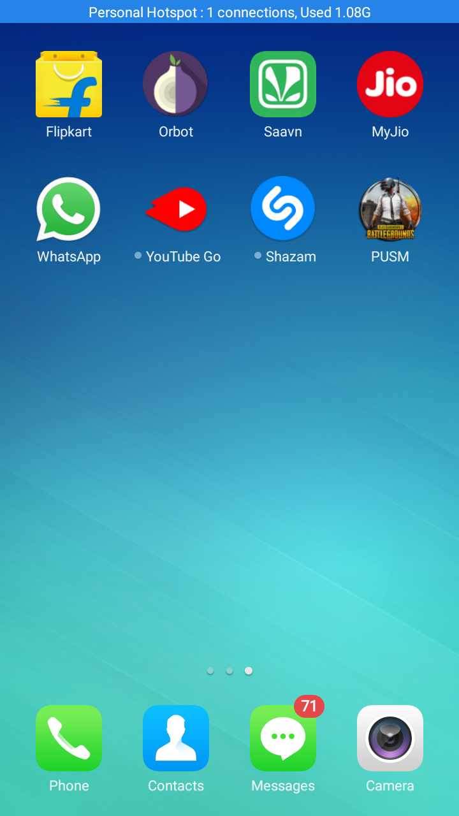

**BY:-**

ANIRUDDHA BHATTACHARYA

BTech(CS-Cloud Computing)

Section: D

Roll No:06

**SUBMITTED TO:-**

MR.SACHIN SHARMA

Associate Dean, International Affairs,

Associate Professor, Department of Computer Science and Engineering,

Graphic Era Deemed to be University,

**INTRODUCTION**

**Vuforia Augmented Reality SDK**

**Vuforia** is an [augmented reality](https://en.wikipedia.org/wiki/Augmented_reality) [software development kit](https://en.wikipedia.org/wiki/Software_development_kit) (SDK) for mobile devices that enables the creation of augmented reality applications. It uses computer vision technology to recognize and track planar images (Image Targets) and simple 3D objects, such as boxes, in real time. This image registration capability enables developers to position and orient [virtual objects](https://en.wikipedia.org/wiki/Virtual_object), such as [3D models](https://en.wikipedia.org/wiki/3D_modeling) and other media, in relation to real world images when they are viewed through the camera of a mobile device. The virtual object then tracks the position and orientation of the image in real-time so that the viewer's [perspective](https://en.wikipedia.org/wiki/Perspective_(visual)) on the object corresponds with the perspective on the Image Target. It thus appears that the virtual object is a part of the real-world scene.

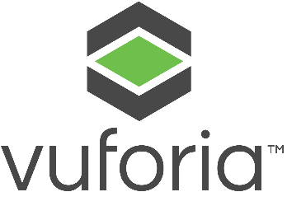The Vuforia SDK supports a variety of 2D and 3D target types including ‘marker less’ Image Targets, 3D Multi-Target configurations, and a form of addressable Fiducial Marker, known as a VuMark. Additional features of the SDK include localized Occlusion Detection using ‘Virtual Buttons’, runtime image target selection, and the ability to create and reconfigure target sets programmatically at [runtime](https://en.wikipedia.org/wiki/Runtime_code_generation).

Vuforia provides [Application Programming Interfaces](https://en.wikipedia.org/wiki/Application_Programming_Interface) (API) in [C++](https://en.wikipedia.org/wiki/C%2B%2B), [Java](https://en.wikipedia.org/wiki/Java_(programming_language)), [Objective-C++](https://en.wikipedia.org/wiki/Objective-C%2B%2B) (a language utilizing a combination of C++ and Objective-C syntax), and the [.NET](https://en.wikipedia.org/wiki/.NET_Framework) languages through an extension to the [Unity game engine](https://en.wikipedia.org/wiki/Unity_game_engine). In this way, the SDK supports both native development for iOS and Android while it also enables the development of AR applications in Unity that are easily portable to both platforms. AR applications developed using Vuforia are therefore compatible with a broad range of mobile devices including the [iPhone](https://en.wikipedia.org/wiki/IPhone), [iPad](https://en.wikipedia.org/wiki/IPad), and [Android phones](https://en.wikipedia.org/wiki/Android_phone) and tablets running [Android OS](https://en.wikipedia.org/wiki/Android_OS) version 2.2 or greater and an [ARMv6](https://en.wikipedia.org/wiki/ARMv6) or 7 processor with FPU ([Floating Point Unit](https://en.wikipedia.org/wiki/Floating_Point_Unit)) processing capabilities.

**Unity (Game Engine)**

**Unity** is a [cross-platform](https://en.wikipedia.org/wiki/Cross-platform) [game engine](https://en.wikipedia.org/wiki/Game_engine) developed by [Unity Technologies](https://en.wikipedia.org/wiki/Unity_Technologies), first announced and released in June 2005 at [Apple Inc.](https://en.wikipedia.org/wiki/Apple_Inc.)'s [Worldwide Developers Conference](https://en.wikipedia.org/wiki/Apple_Worldwide_Developers_Conference) as an [OS X](https://en.wikipedia.org/wiki/MacOS)-exclusive game engine. As of 2018, the engine has been extended to support 27 platforms. The engine can be used to create both [three-dimensional](https://en.wikipedia.org/wiki/Three-dimensional_space) and [two-dimensional](https://en.wikipedia.org/wiki/Two-dimensional_space) games as well as [simulations](https://en.wikipedia.org/wiki/Computer_simulation) for its many platforms.

**PHASE I: INSTALLATION PROCESS**

**In this Phase, we are going to Install the Unity Software and configure it with the Vuforia and the android plugins and SDK respectively. And we will also be going to configure the Vuforia Cloud for the Project Development.**

**Step 1**: Download Unity Game Editor and Install it in Your PC or Laptop.

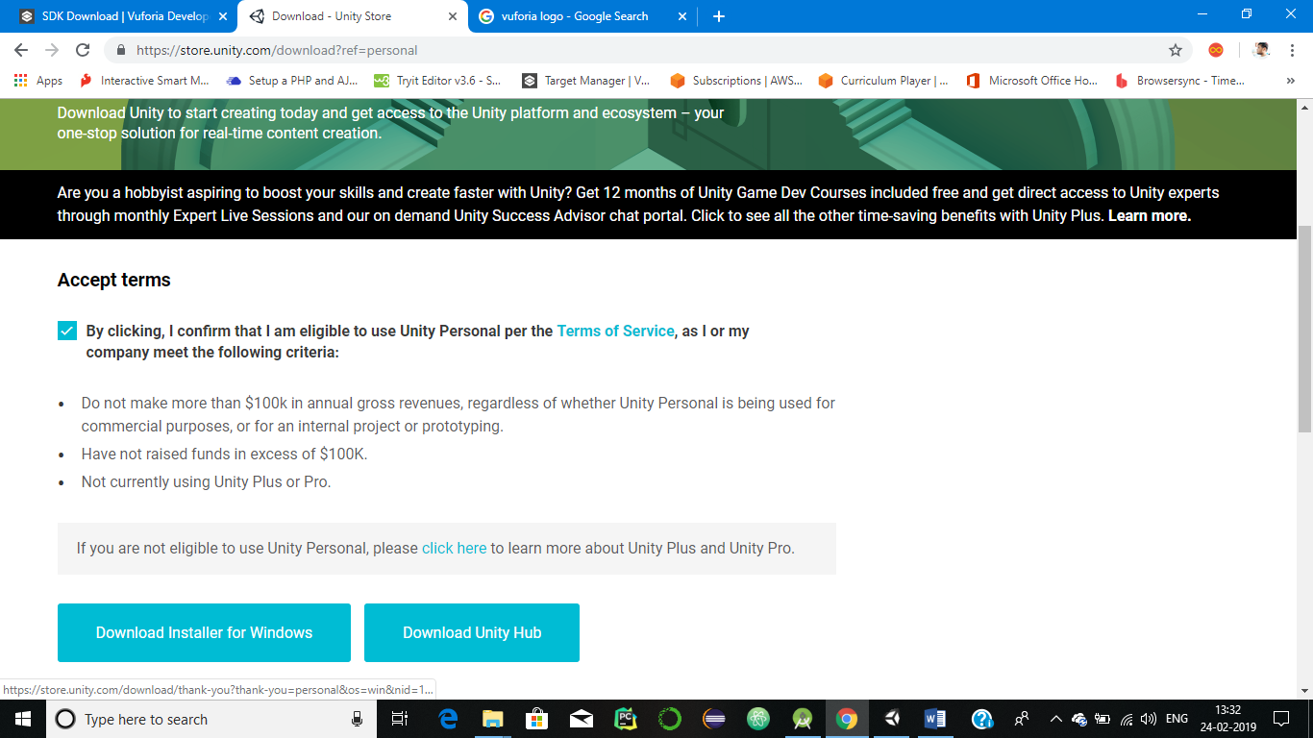

**Step 2**: Download Vuforia Plugins from the Download section of Vuforia’s Website.

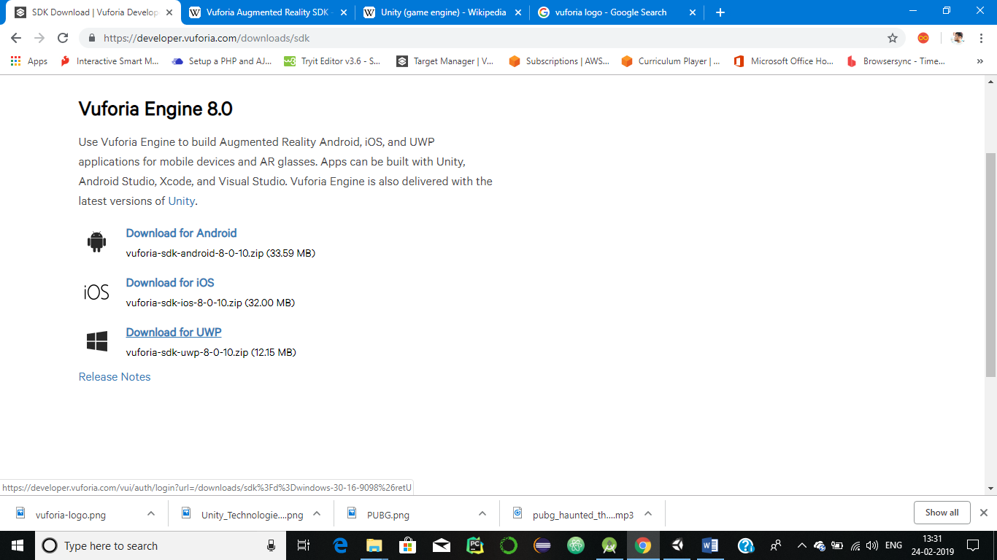

**Step 3**: Login To your Vuforia Account.

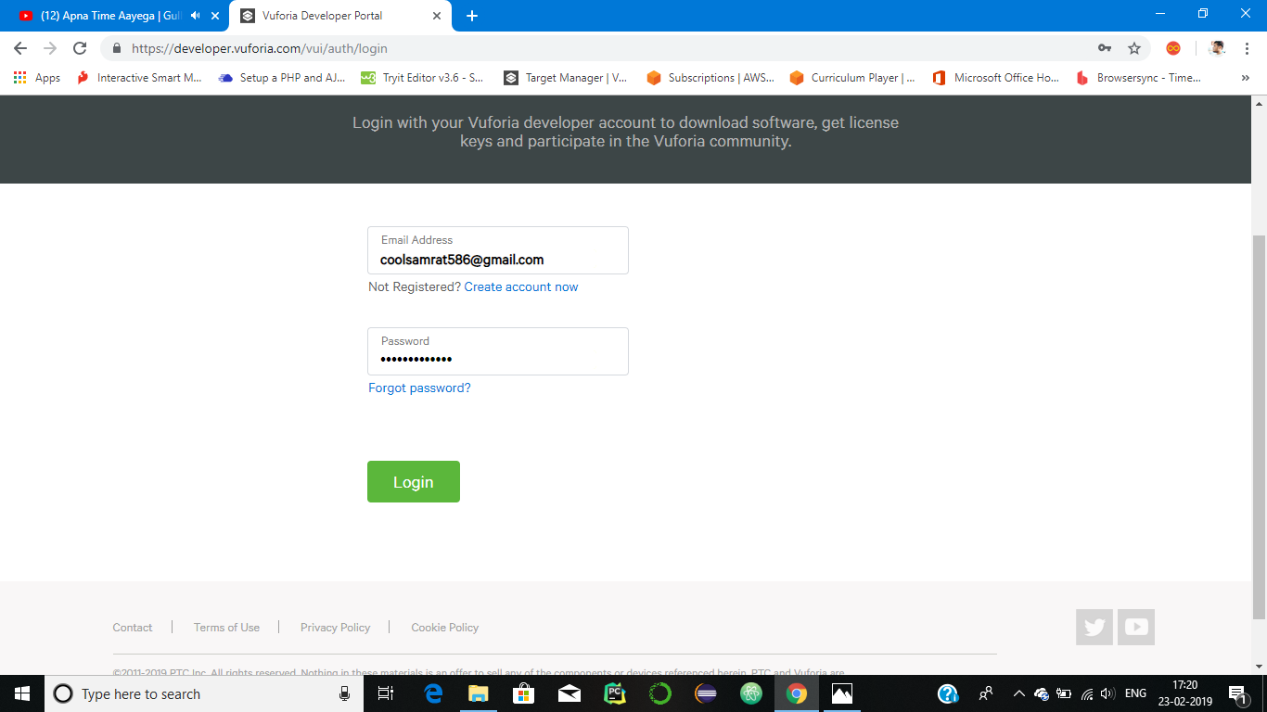

**Step 4**: Now we are at our Vuforia’s Developer Dashboard and Click Get Development Key Button.

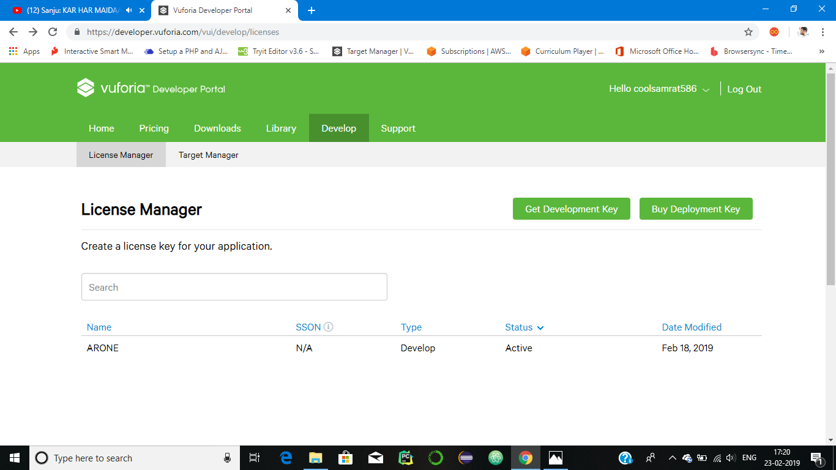

**Step 5**: Name Our First App as ARONE.

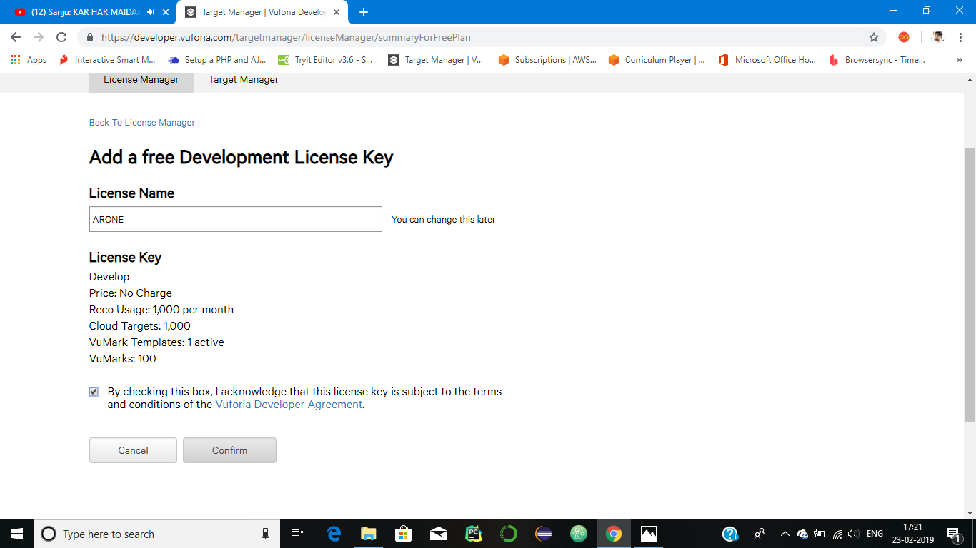

**Step 6**: Now we get the Development Key.

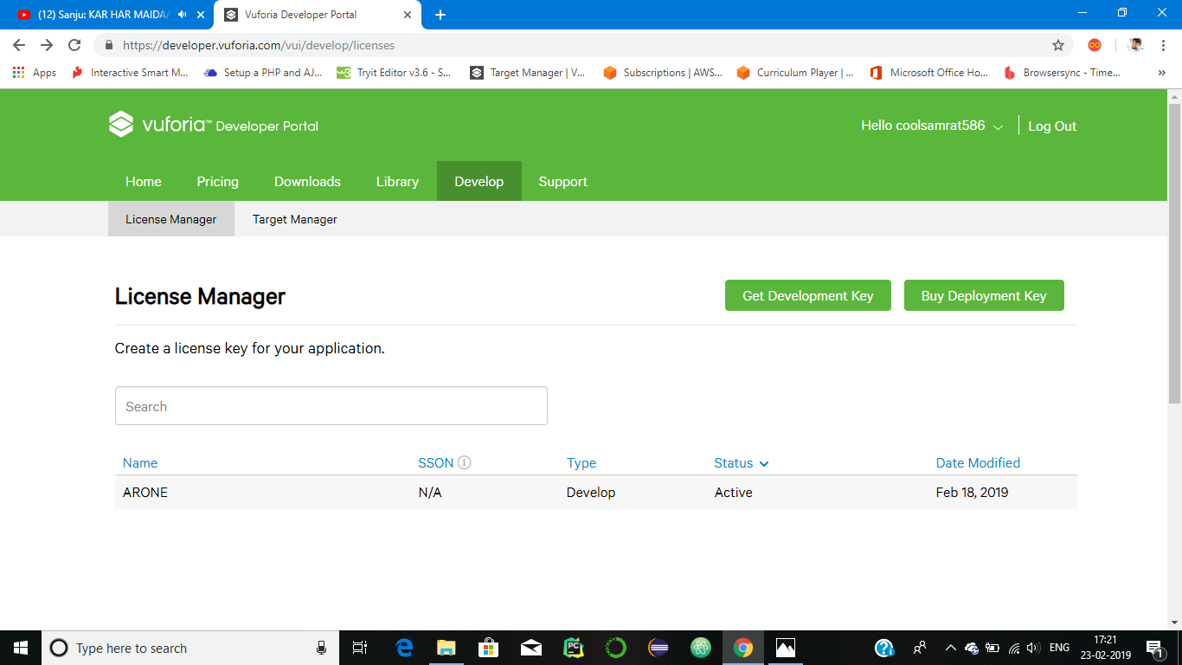

**Step 7**: Click on the ARONE Key and we will get a License Key over there.

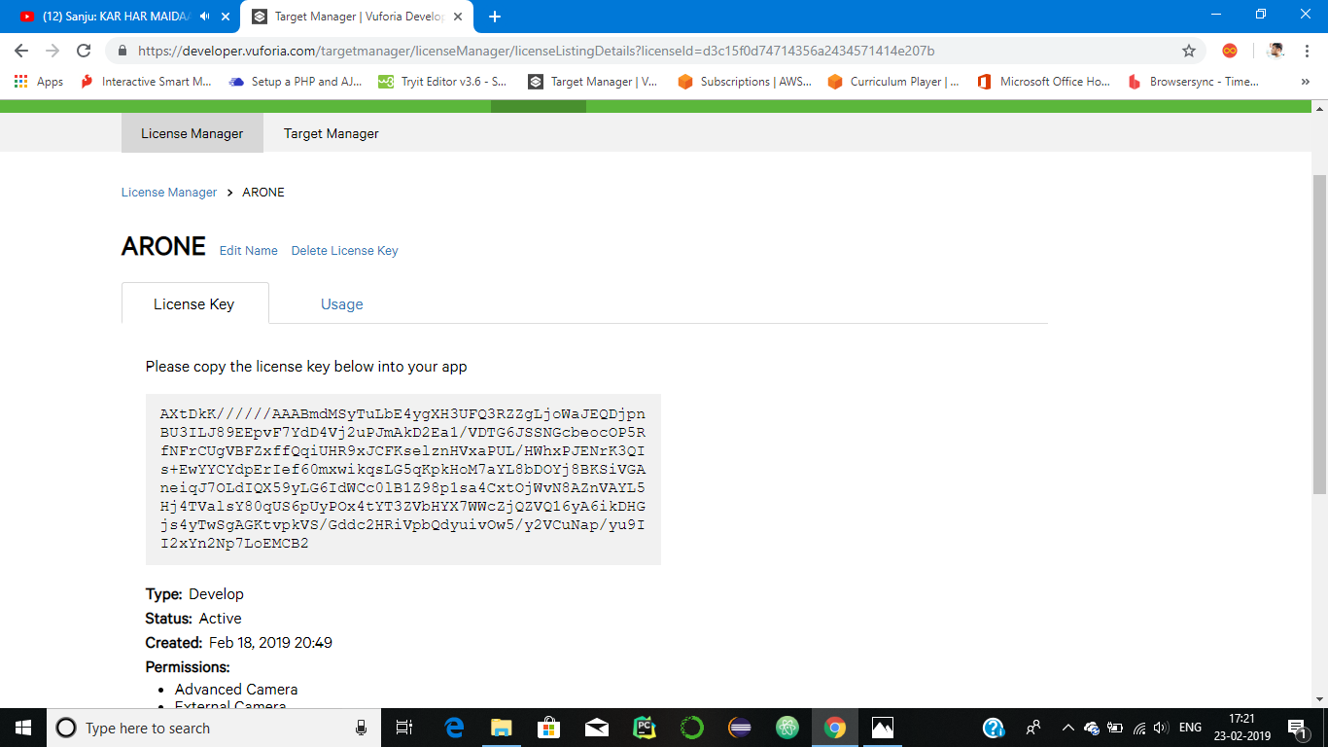

**Step 8**: Now go to The Target Manager and Create a database for the Project and name it as ARONEDATABASE and set the Type as Device.

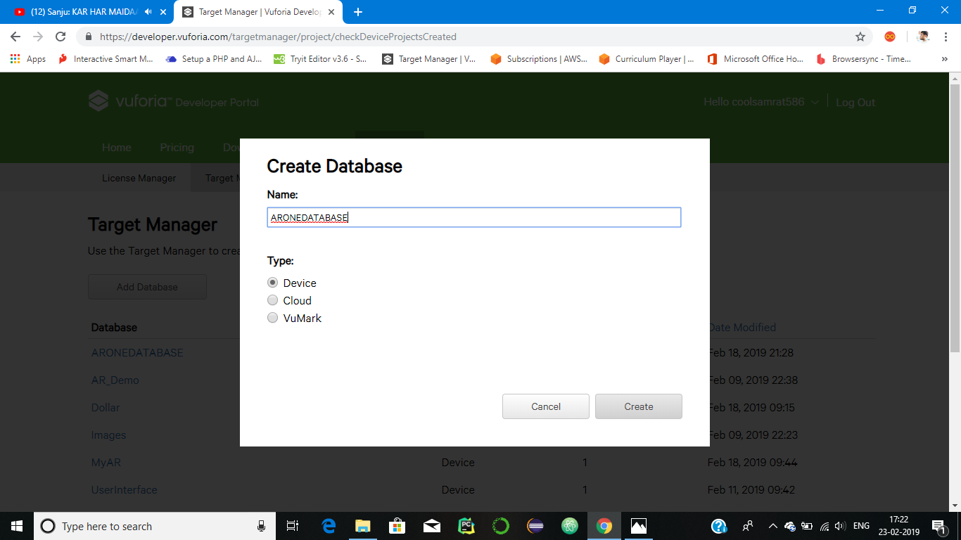

**Step 9**: Click on the Database you created and now add your Target Image by clicking Add Target Button.

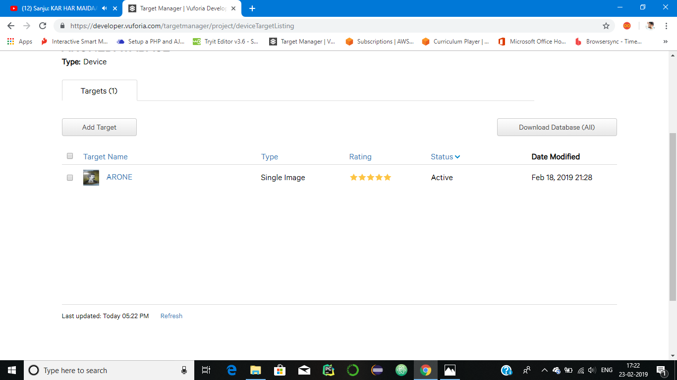

**Step 10**: At last Download the Database.

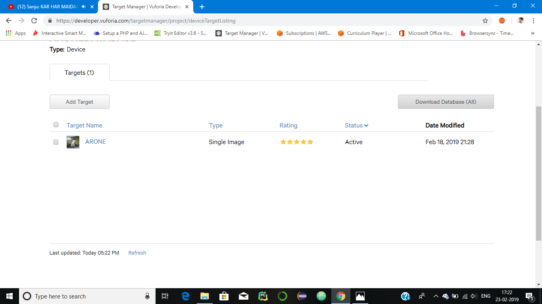

**PHASE II: WORKING PROCESS**

**Step 11:** Start your Unity Software and create project and name it as final_project

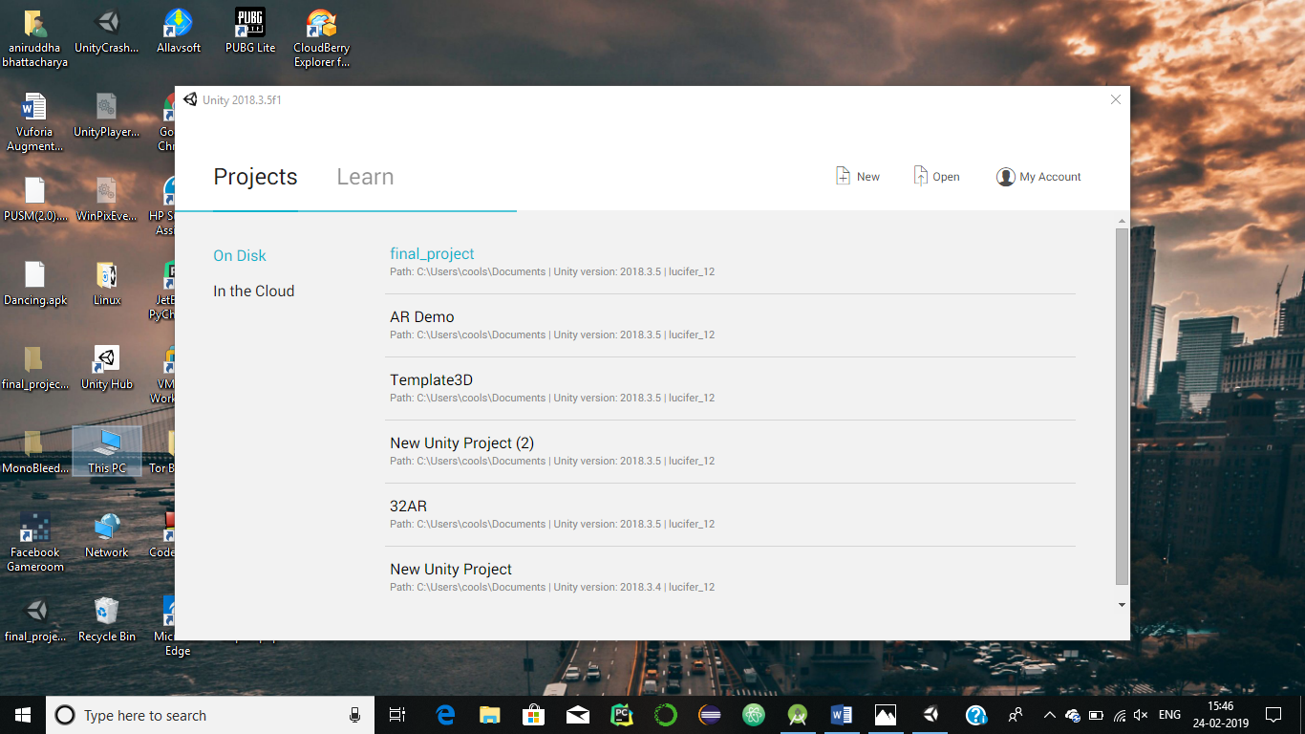

**Step 12**: Delete the Main Camera and Import the AR Camera (Right Click->Vuforia Engine->AR Camera).

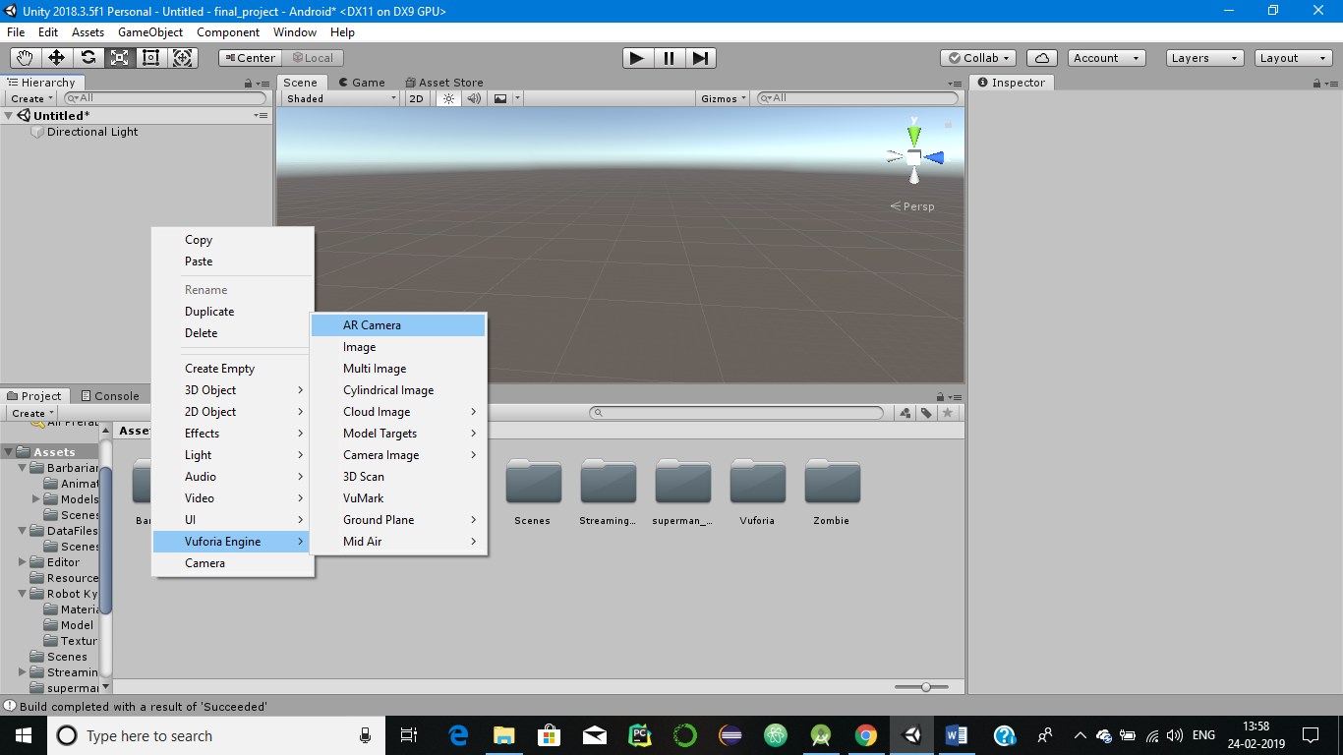

**Step 13**: Import the Database that we have downloaded from Vuforia.

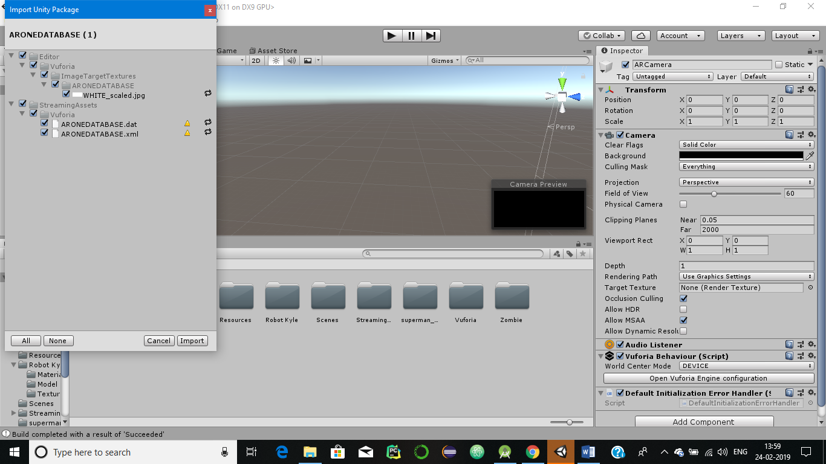

**Step 14:** Add the License Key and the Database that we get from Vuforia.

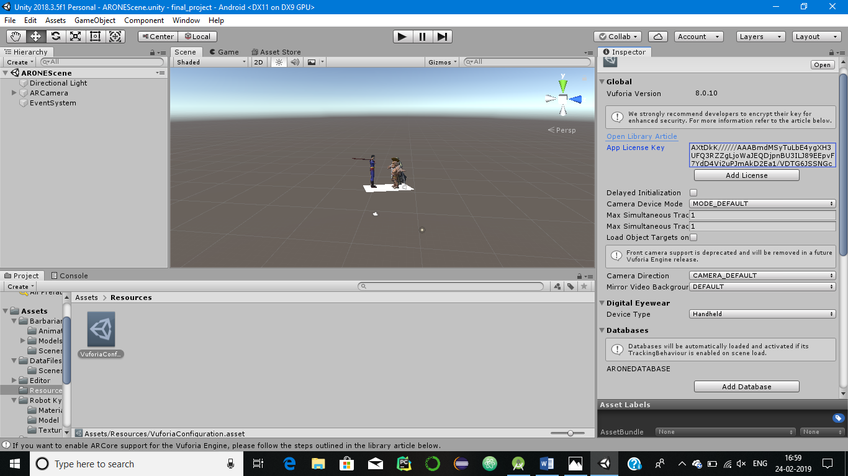 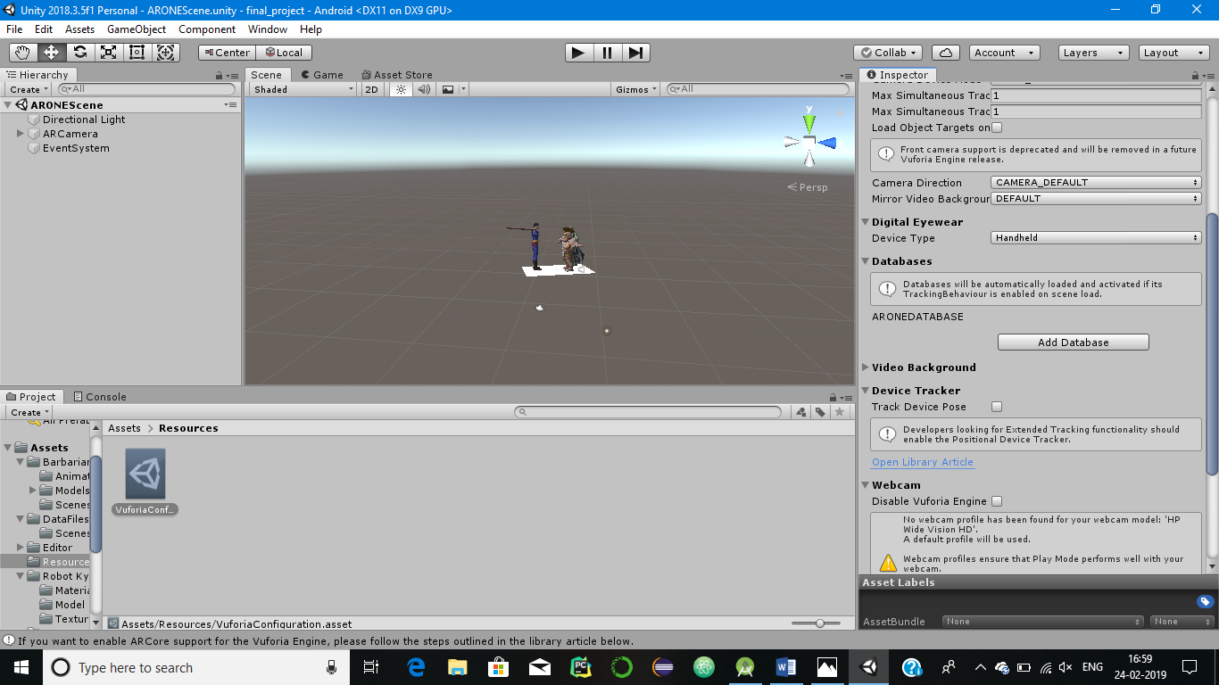

**Step 15**: Now it’s time to add the image target to our unity project which we have uploaded on Vuforia.

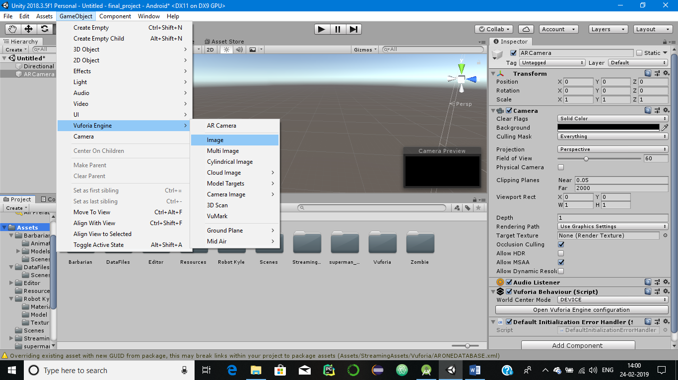

**Step 16**: The ImageTarget is now added to the Hierarchy.

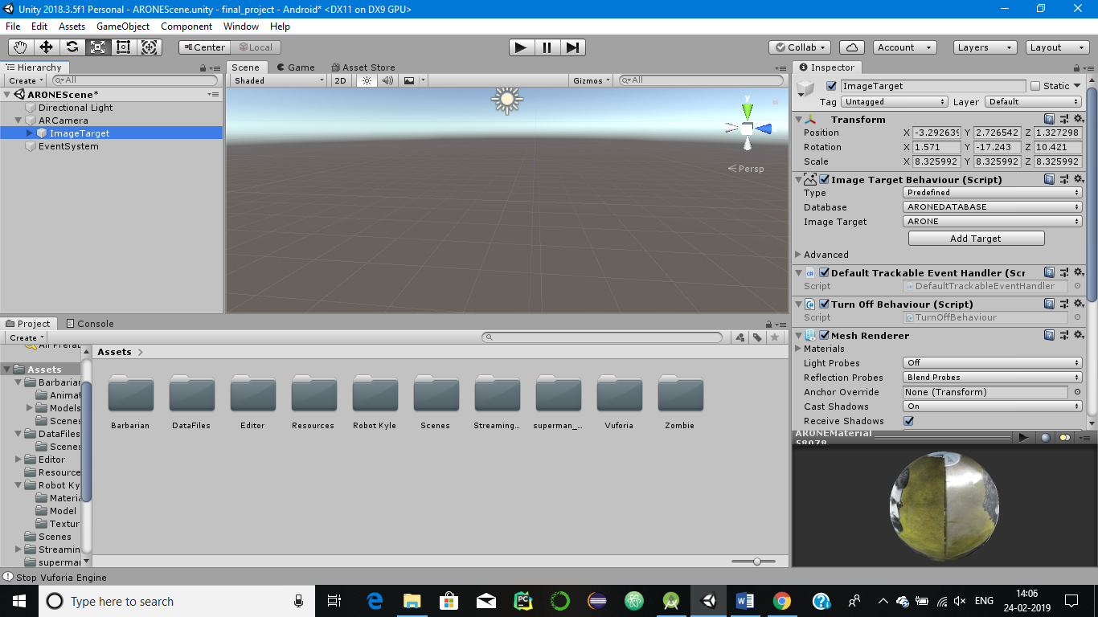

**Step 17**: Download and Import all the character models into your Scene from the Assert Store or Externally and import an audio file of PUBG.

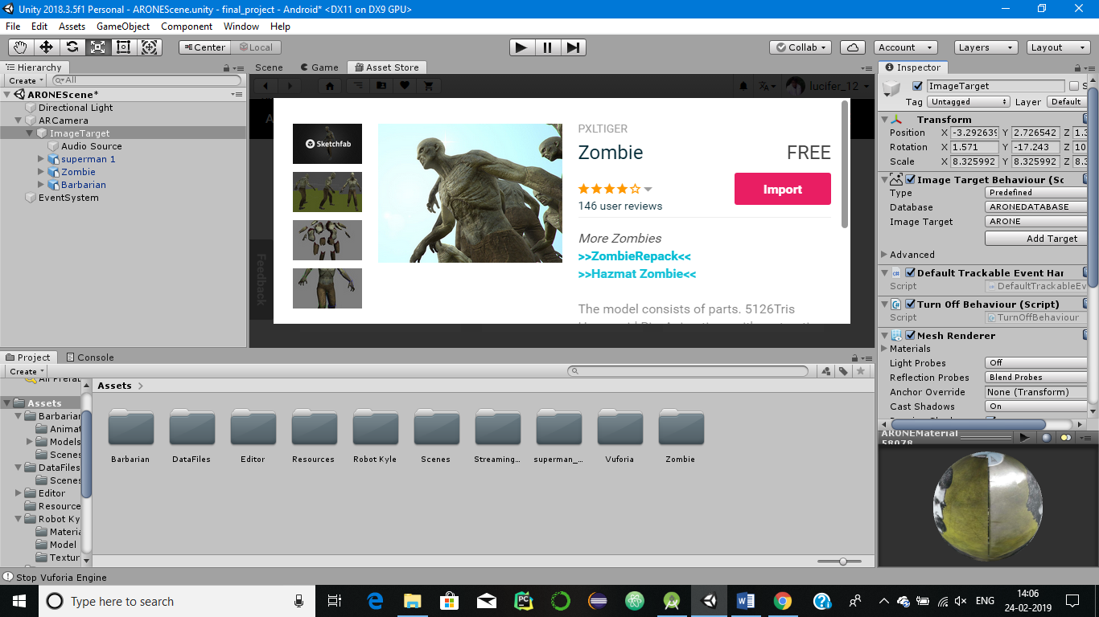 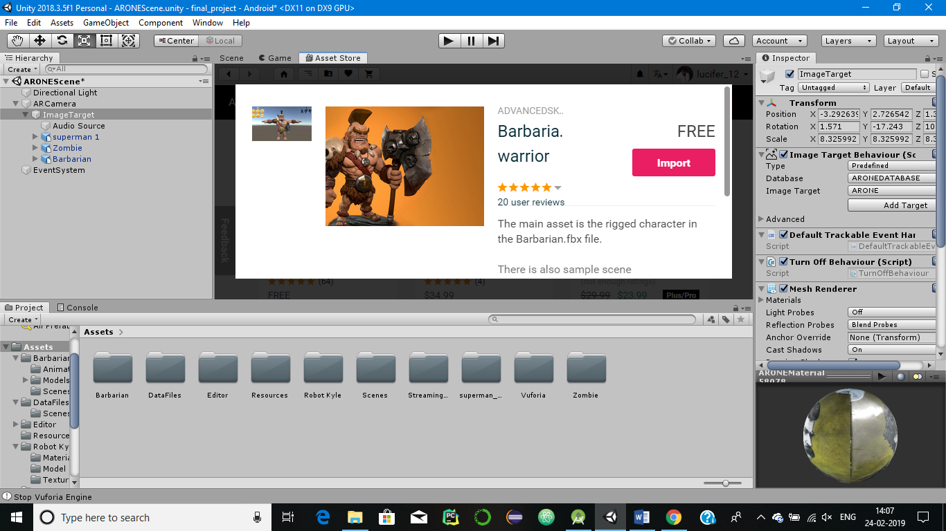

**Step 18**: Add all the characters under the heirarchy of ImageTarget and Adjust or Animate them accordingly.

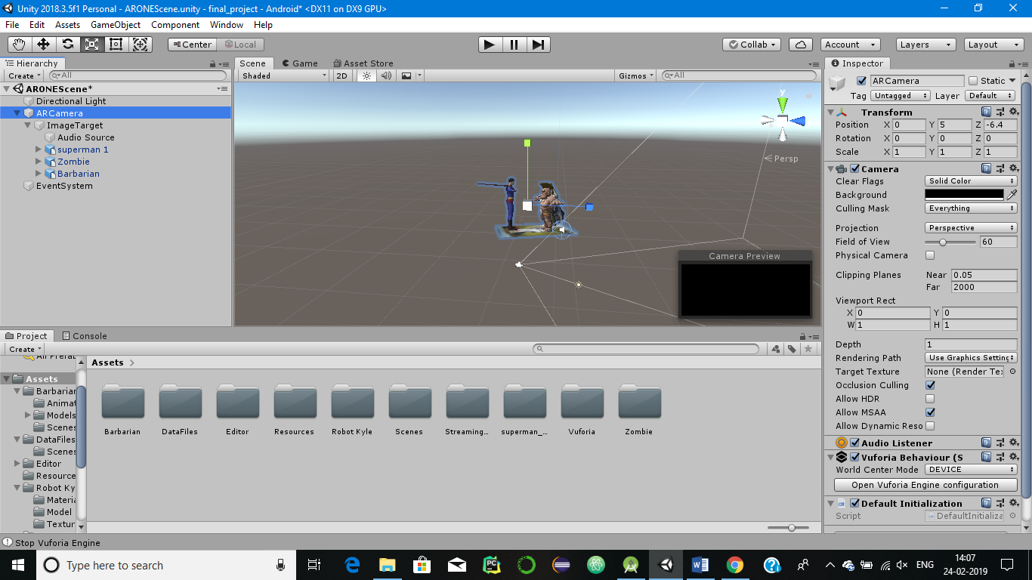

**Step 19**: Click the Play button to see the effects.

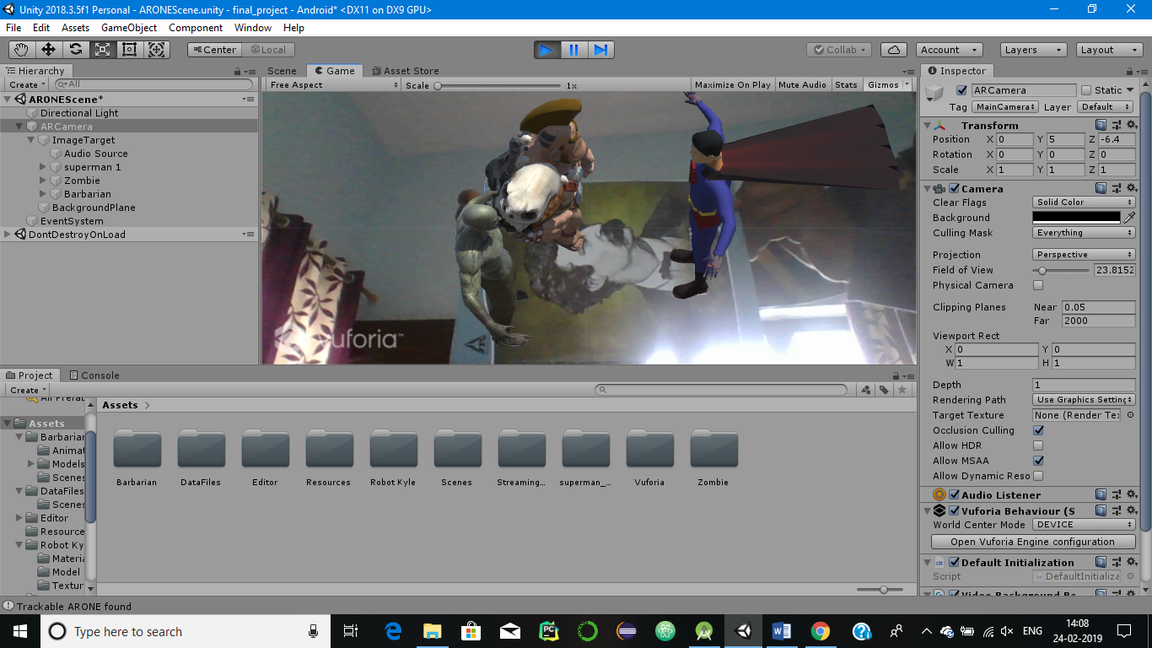

**PHASE III: CREATE THE ANDROID APP**

**Step 20**: Download and Install Android Studio with SDK and Gradle.

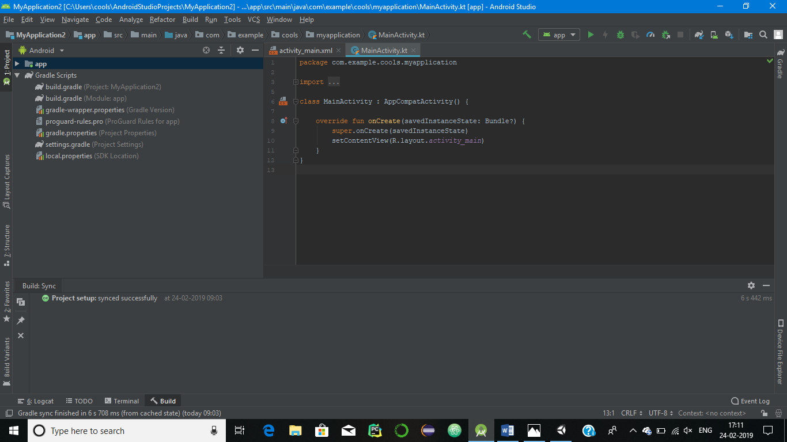

**Step 21**: Now goto Edit->Preferences->External Tools and add the Browse SDK and JDK.

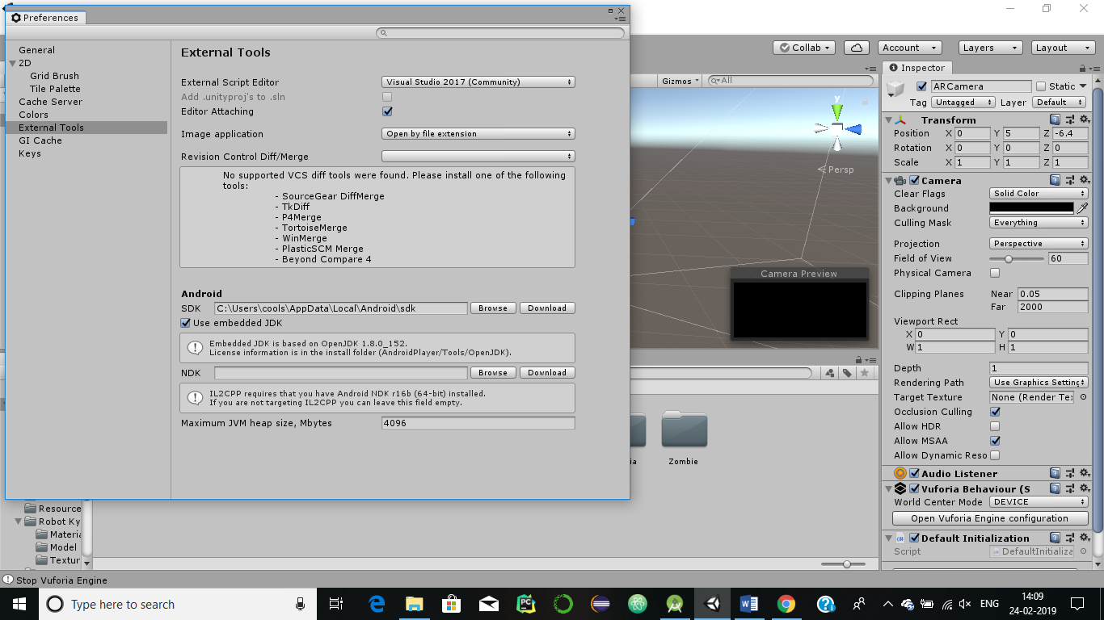

**Step 22**: Goto File->Build Settings and change the Platform to Android and Click on Build.

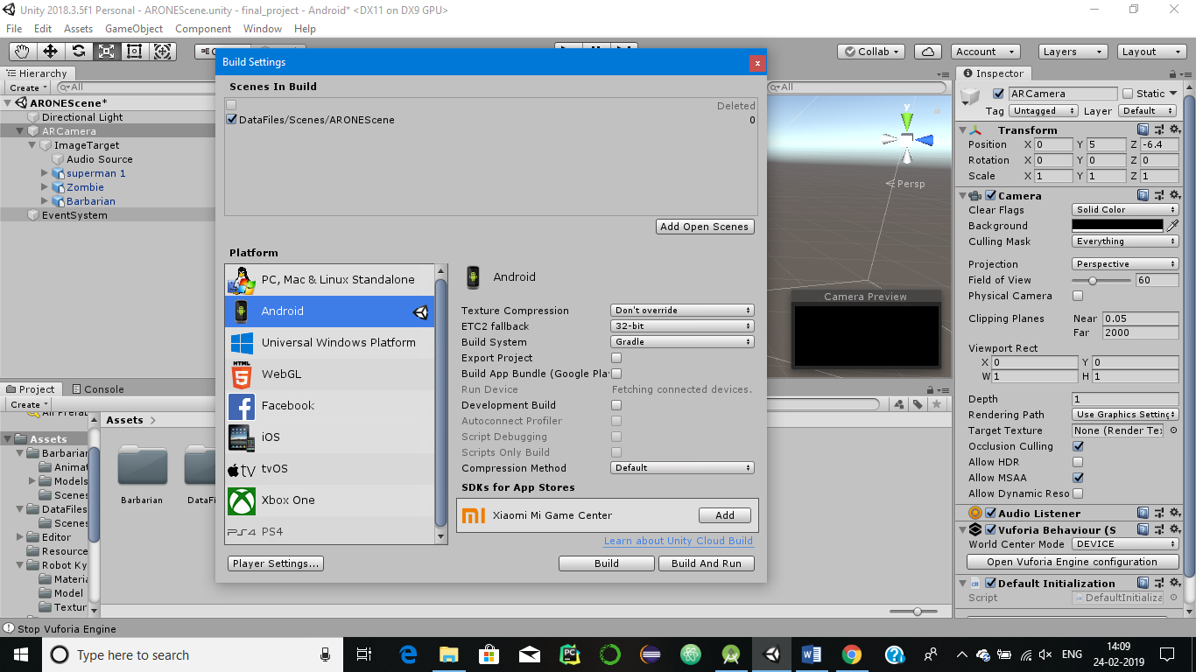

**Step 23**: Now Click the Player Settings and change the following:-

1. Company Name: AniruddhaBhattacharya
2. Product Name : PUSM
3. Version : 2.0
4. Package Name : com.AniruddhaBhattacharya.pusm

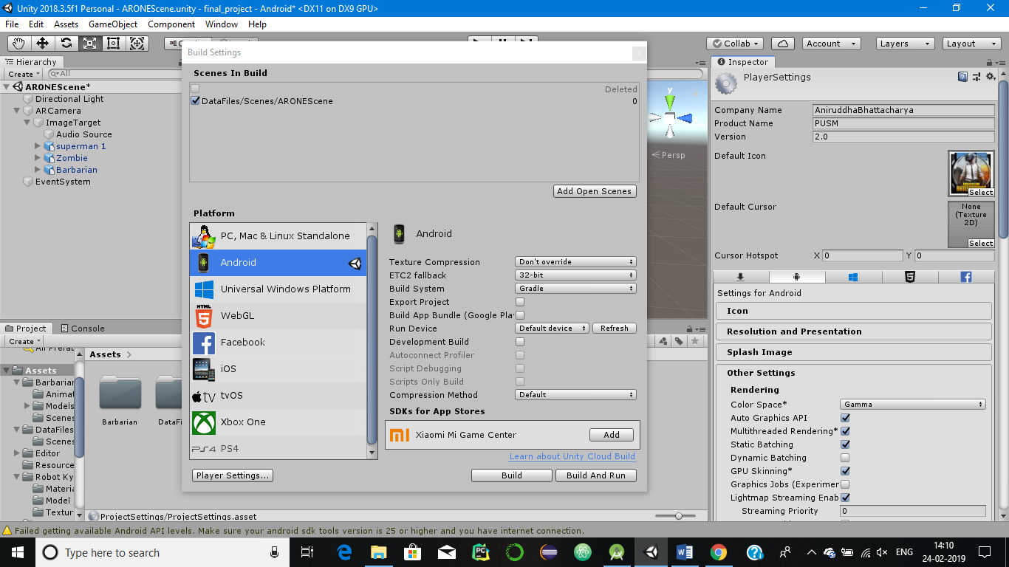 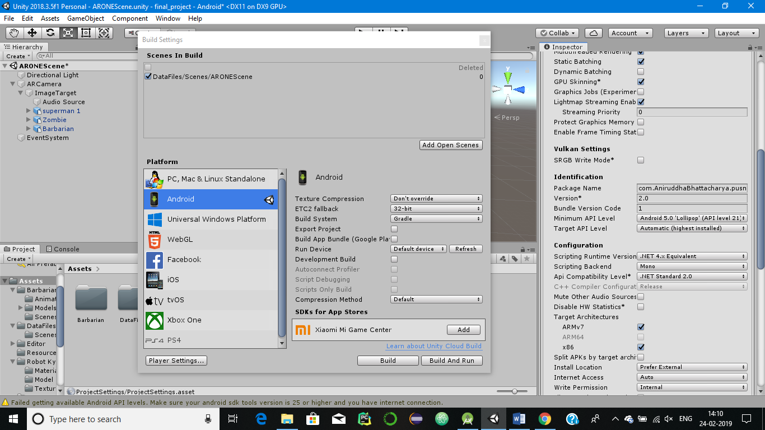

**Step 24**: Now Save your file as PUSM.apk and run it on your android mobile.

